Pritzker Family Foundation Foundant access: <https://www.grantinterface.com/Home/Logon?urlkey=pritzkerfoundation>

We recommend that you bookmark this page in your browser.

SITE ACCESS & EDITING YOUR ACCOUNT

Video Tutorial: <https://drive.google.com/file/d/1O2-rkkxy9iQ1WLx2LKaBYr9LgFoXfaqt/view>

To apply for grants from the JB & MK Pritzker Family Foundation (PFF), you must use our online application system called Foundant

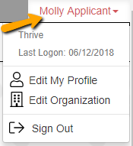If you wish to edit your account information or change your password, click your name in the type right.  This will expand a drop-down menu. If you click Edit my profile, you will be able to update your user information or change your password.  Be sure to click save in the bottom right once you’ve finished.

Please note, that you will be automatically logged out of the system after 90 minutes of inactivity (you will receive a warning message at 80 minutes of the pending “time out”).

APPLYING FOR FUNDING

Video Tutorial: <https://drive.google.com/file/d/1cmTa7Hmacg4pqJpn5Xo92vp3RzRxfoeS/view>

Upon completing registration and accessing the system for the first time, you will land on the **Apply Page**.

* PFF’s applications are invite only. Use the access code provided to you by your program officer to reveal the opportunity you have been invited to apply to.
* You can preview the application without having to save any work by clicking **Preview**.
* To start a request, click **Apply** under the opportunity you’d like to apply to.
  + Clicking **Apply** will take you into a form to complete and submit.

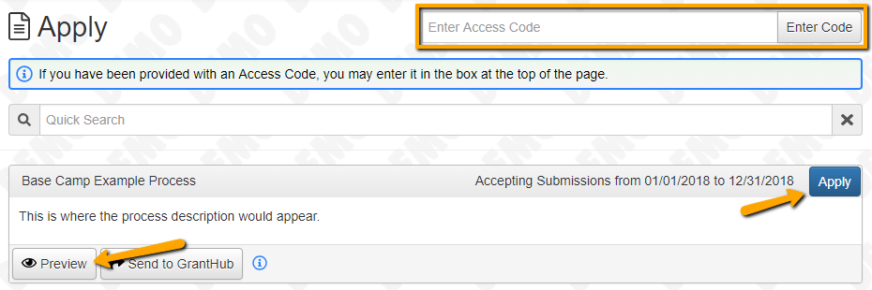

Once in the form, note that your contact and organization information automatically populates at the top of the form.

* You may update your contact information and view your email history.
* Once you’ve completed the form, you may click the Application Packet button to download a copy of the questions and your responses.
* Please note that if the application has a specific deadline it will be listed at the top of the form.

Work your way through the form responding to the fields.

* Note that any fields with an asterisk are required fields and must be completed prior to submitting an application.
* As you complete the application, the system will auto-save every 100 characters typed or every time you click out of a field. It’s still a good idea to occasionally hit **Save Application** on the very bottom of the page, including before exiting the application.
* You may collapse question groups as you go, once you’ve finished all of the questions in that group. This will reduce your need to scroll.
* The individual response fields have character limits. Responses that are longer than the set limit will be saved, but an error message will appear stating that the limit has been exceeded.
  + If you’ve exceeded the number of characters, you will not be allowed to submit the form until the length of the response has been decreased.
* File **upload fields** will only accept one file, per field.
  + Upload fields have size limits.
    - If you attempt to upload a file that is larger than the defined limit, you will receive an error message stating that the file is too large and the file **will not** be saved.
    - You can make PDFs smaller by using compression tools like Compress PDF: <https://smallpdf.com/compress-pdf>
  + Upload fields may also have file type restrictions.
    - If you attempt to upload a file type in an unaccepted file type acceptable file type you will receive a warning that the file type is not acceptable and you will not be able to upload the file.
  + Once a file has been uploaded, it may be deletedby clicking the **Red X** next to the file name. After that, a new file can be uploaded.
* After saving and exiting the system, you will be able to access your draft application from the **Dashboard** the next time you log in. You can pick back up where you left off by clicking **Edit** link to the right of the request.
* When all of the fields are complete, submit the application.
* If any required fields were not completed, or a response to a text question type is longer than the set limit, the system will not allow the form to be submitted.
  + An error message appears listing the fields that need to be completed or edited.
  + These fields are outlined in red so they are easy to identify as the applicant scrolls through the form.
* When a form is submitted successfully, you will be taken to a confirmation page.
  + When you click **Continue,** you can view your submitted request, but you will no longer be able to edit it.

APPLICANT DASHBOARD

Video Tutorial: <https://drive.google.com/file/d/155ta4kdwfWbiSnftjux_PGJHfMkse5Bz/view>

Your dashboard houses current and historical requests.

The active request tab houses all current requests. These are the requests still requiring action, awaiting a decision and/or requests that have not yet been marked closed by the site administrator. Within each request you can see forms, form statuses, submission dates, and form deadlines.

* You may continue working on saved forms by clicking the edit option next to the form.
* You may view forms that have been submitted but note that once submitted you cannot edit them. You can also see the request’s decision status. The status will be “Undecided” until the site administrator posts a decision.

If your request is approved you may be assigned **Follow-Up Reports** to be completed and submitted through the system.

* **Follow Ups** are completed and submitted just like any other form.
* If you’ve been assigned multiple follow-up forms, you must complete them sequentially by due date. Follow ups that are past due will be marked as such.

